Supplementary Information

Supplementary Figures and Tables
Behaviour | Two-way ANOVA  Inactive lever presses | Two-way ANOVA  Wasted lever presses
Acquisition  Cocaine SA (0,2 mg/kg) | Session: F_{12,360}=1.19, p=0.28, NS  Genotype: F_{2, 30}= 0.17, p=0.84, NS  Interaction: F_{24, 360} = 0.83, p=0.7, NS | F_{12,360}=1.08, p=0.38, NS  F_{2, 30}= 0.1, p=0.9, NS  F_{24, 360} = 0.63, p=0.91, NS
Dose-response (0,1-0,8 mg/kg) cocaine SA | Cocaine dose: F_{3,75}=7.1, p=0.0003  Genotype: F_{2, 25}= 0.18, p=0.83, NS  Interaction: F_{6, 75} = 1.22, p=0.3, NS | F_{3,75}=9.22, p<0.0001  F_{2, 25}= 0.81, p=0.45, NS  F_{6, 75} = 0.78, p=0.58, NS
Progressive Ratio (0,2-0,4 mg/kg) cocaine SA | Cocaine dose: F_{1,23}=15.08, p=0.0008  Genotype: F_{2, 23}= 0.37, p=0.69, NS  Interaction: F_{2, 23} = 0.23, p=0.8, NS | F_{1,23}=3.36, p=0.08, NS  F_{2, 23}= 3.23, p=0.058, NS  F_{2, 23} = 2.85, p=0.078, NS
Cue-induced reinstatement | Reinstatement: F_{1,23}=4.23, p=0.051, NS  Genotype: F_{2, 23}= 0.46, p=0.64, NS  Interaction: F_{2, 23} = 0.58, p=0.57, NS
Stress-induced reinstatement | Reinstatement: F_{1,23}=7.62, p=0.011  Genotype: F_{2, 23}= 0.12, p=0.88, NS  Interaction: F_{2, 23} = 0.03, p=0.97, NS
Cocaine (10 mg/kg)-induced reinstatement | Reinstatement: F_{1,23}=0.05, p=0.82, NS  Genotype: F_{2, 23}= 0.29, p=0.74, NS  Interaction: F_{2, 23} = 1.36, p=0.28, NS

Table S1: Statistics on inactive lever and perseverative responding (wasted lever presses during the time-out period) during cocaine self-administration (SA) of WT, α5SNP and α5KO rats.
Two-way ANOVAs performed on inactive or wasted lever presses during the different phases of the cocaine SA study.

Behaviour | WT | α5SNP | α5KO | One-way ANOVA
Acquisition  FR-1 | 2.45  +/- 0.15 | 2.5  +/- 0.17 | 2.58  +/- 0.15 | F (2, 30) = 0.18  P = 0.83, NS
Acquisition  FR-2 | 2  +/- 0 | 2  +/- 0 | 2  +/- 0 | Not Applicable  (SEMs=0)
Acquisition  FR-3 | 2.27  +/- 0.14 | 2.2  +/- 0.13 | 2.33  +/- 0.14 | F (2, 30) = 0.23  P = 0.8, NS
Acquisition  FR-4 | 2  +/- 0 | 2  +/- 0 | 2  +/- 0 | Not Applicable  (SEMs=0)
Acquisition  FR-5 | 2.36  +/- 0.15 | 2.6  +/- 0.16 | 2.67  +/- 0.14 | F (2, 30) = 1.12  P = 0.34, NS
Extinction | 6.77  +/- 0.6 | 5  +/- 0.5 | 6.1  +/- 0.45 | F (2, 23) = 2.86  P = 0.0776, NS

Table S2: Number of sessions to reach the criterion during cocaine self-administration (SA) of WT, α5SNP and α5KO rats.
The one-way ANOVAs were performed on the number of sessions to reach the criterion during the different phases of the cocaine SA study.

 |  | Mean (SD) or N (%)
Age |  | 39 (9)
Gender | Men | 234 (76%)
 | Women | 72 (24%)
Homelessness ≥3 months |  | 89 (29%)
At least one lifetime SA |  | 115 (38%)
Number of cigarettes smoked / day |  | 18 (11)
3 comorbid lifetime SUDs or more (except tobacco) |  | 257 (44%)
Lifetime SUD diagnoses | Opiates | 129 (42%)
 | Alcohol | 224 (75%)
 | Cannabis | 243 (81%)
 | Sedatives | 170 (56%)
Age at onset of cocaine use (years) |  | 23 (6)
Weekly cocaine use during self-reported worst period of CUD (daily vs. non-daily) |  | 191 (62%)
Number of DSM-IV criteria for CUD |  | 4.9 (1.8)
Delay to relapse from CUD after cessation (months): Mean (SD)  Median (IQR) |  | 37 (58)  13 (4-36)

Table S3: description of the clinical sample with data about CUD relapse after removal of outliers, N =306. SD, standard deviation; SUD, substance use disorder; CUD, cocaine use disorder; IQR, interquartile range.

SNP ID | Position on chr15 (bp) | alleles | MAF in the European superpopulation | distance from rs950776 (bp) | LD |  | NES | NES x R2
 |  |  |  |  | D' | R2
rs950776 | 78926018 | (T/C) | 0.325 | 0 | 1 | 1 | 0.63 | 0.63
rs8023462 | 78914734 | (C/T) | 0.336 | -11284 | 0.9816 | 0.917 | -0.64 | -0.58688
rs2904130 | 78916622 | (C/G) | 0.335 | -9396 | 0.977 | 0.9126 | -0.64 | -0.584064
rs4887070 | 78916187 | (C/T) | 0.338 | -9831 | 0.9815 | 0.9088 | -0.63 | -0.572544
rs62010332 | 78918762 | (G/C) | 0.325 | -7256 | 0.9275 | 0.8603 | 0.63 | 0.541989
rs1948 | 78917399 | (A/G) | 0.3191 | -8619 | 0.9262 | 0.8346 | -0.65 | -0.54249
rs7178270 | 78921077 | (C/G) | 0.3638 | -4941 | 0.9904 | 0.826 | 0.69 | 0.56994
rs62010327 | 78892784 | (G/A) | 0.34 | -33234 | 0.9212 | 0.7935 | 0.68 | 0.53958
rs7495518 | 78900574 | (C/T) | 0.333 | -25444 | 0.89 | 0.764 | 0.67 | 0.51188
rs62010328 | 78894971 | (C/T) | 0.333 | -31047 | 0.89 | 0.764 | 0.66 | 0.50424
rs2869546 | 78907345 | (C/T) | 0.3499 | -18673 | 0.92 | 0.7574 | -0.69 | -0.522606
rs2067808 | 78911780 | (G/A) | 0.3509 | -14238 | 0.9199 | 0.7539 | 0.66 | 0.497574
rs3743075 | 78909452 | (T/C) | 0.341 | -16566 | 0.8886 | 0.7351 | -0.7 | -0.51457
rs79609284 | 78928411 | (G/A) | 0.336 | 2393 | 0.8757 | 0.7298 | 0.63 | 0.459774
rs3743074 | 78909480 | (G/A) | 0.3429 | -16538 | 0.8883 | 0.7281 | -0.69 | -0.502389
rs111725959 | 78899346 | (G/A) | 0.3429 | -26672 | 0.8883 | 0.7281 | 0.67 | 0.487827
rs7182583 | 78899210 | (G/C) | 0.3429 | -26808 | 0.8883 | 0.7281 | 0.67 | 0.487827
rs514743 | 78884227 | (T/A) | 0.3429 | -41791 | 0.8883 | 0.7281 | -0.68 | -0.495108
rs17408276 | 78881618 | (T/C) | 0.3429 | -44400 | 0.8883 | 0.7281 | 0.67 | 0.487827
rs3743073 | 78909539 | (G/T) | 0.3439 | -16479 | 0.8881 | 0.7246 | -0.69 | -0.499974
rs472054 | 78887994 | (A/G) | 0.3439 | -38024 | 0.8881 | 0.7246 | -0.67 | -0.485482
rs660652 | 78887832 | (A/G) | 0.3439 | -38186 | 0.8881 | 0.7246 | -0.67 | -0.485482
rs615470 | 78885988 | (T/C) | 0.3439 | -40030 | 0.8881 | 0.7246 | -0.67 | -0.485482
rs584135 | 78883628 | (A/G) | 0.3439 | -42390 | 0.8881 | 0.7246 | -0.68 | -0.492728
rs692780 | 78876505 | (C/G) | 0.3419 | -49513 | 0.8745 | 0.7088 | -0.69 | -0.489072
rs61012457 | 78865694 | (C/G) | 0.3419 | -60324 | 0.8745 | 0.7088 | 0.68 | 0.481984
rs57945453 | 78862845 | (C/T) | 0.3419 | -63173 | 0.8745 | 0.7088 | 0.72 | 0.510336
rs11637635 | 78877150 | (A/G) | 0.3429 | -48868 | 0.8743 | 0.7054 | -0.69 | -0.486726
rs471889 | 78870235 | (T/C) | 0.3449 | -55783 | 0.874 | 0.6986 | -0.65 | -0.45409
rs495090 | 78870003 | (A/G) | 0.3449 | -56015 | 0.874 | 0.6986 | -0.66 | -0.461076
rs495956 | 78869930 | (C/T) | 0.3449 | -56088 | 0.874 | 0.6986 | -0.66 | -0.461076
rs1878399 | 78912003 | (G/C) | 0.3907 | -14015 | 0.9498 | 0.6777 | -0.71 | -0.481167
rs4352017 | 78912204 | (A/C) | 0.3936 | -13814 | 0.9546 | 0.676 | -0.69 | -0.46644
rs8025188 | 78912278 | (C/G) | 0.3926 | -13740 | 0.9496 | 0.6718 | -0.69 | -0.463542
rs57728226 | 78929350 | (G/C) | 0.3728 | 3332 | 0.9025 | 0.66 | 0.75 | 0.495
rs36045869 | 78929498 | (C/T) | 0.3738 | 3480 | 0.9023 | 0.657 | 0.75 | 0.49275
rs3743077 | 78894896 | (C/T) | 0.3867 | -31122 | 0.9252 | 0.6539 | 0.71 | 0.464269
rs12901300 | 78892952 | (G/A) | 0.3867 | -33066 | 0.9252 | 0.6539 | 0.7 | 0.45773
rs12911602 | 78891449 | (T/C) | 0.3867 | -34569 | 0.9252 | 0.6539 | 0.7 | 0.45773
rs6495307 | 78890321 | (C/T) | 0.3867 | -35697 | 0.9252 | 0.6539 | 0.7 | 0.45773
rs56276142 | 78889795 | (T/C) | 0.3867 | -36223 | 0.9252 | 0.6539 | 0.71 | 0.464269
rs647041 | 78880481 | (T/C) | 0.3867 | -45537 | 0.9252 | 0.6539 | -0.73 | -0.477347
rs77403874 | 78903165 | (T/C) | 0.3887 | -22853 | 0.925 | 0.6481 | 0.68 | 0.440708
rs183822442 | 78902775 | (A/G) | 0.3887 | -23243 | 0.925 | 0.6481 | 0.68 | 0.440708
rs139978901 | 78902026 | (C/A) | 0.3887 | -23992 | 0.925 | 0.6481 | 0.68 | 0.440708
rs6495306 | 78865893 | (G/A) | 0.3877 | -60125 | 0.9201 | 0.644 | -0.76 | -0.48944
rs588765 | 78865425 | (T/C) | 0.3877 | -60593 | 0.9201 | 0.644 | -0.76 | -0.48944
rs555018 | 78879242 | (G/A) | 0.3867 | -46776 | 0.9152 | 0.6399 | -0.76 | -0.486324
rs871058 | 78858491 | (G/A) | 0.3131 | -67527 | 0.8213 | 0.6384 | 0.71 | 0.453264
rs621849 | 78872861 | (G/A) | 0.3897 | -53157 | 0.9198 | 0.6382 | -0.7 | -0.44674
rs10709956 | 78872834 | (A/-) | 0.3897 | -53184 | 0.9198 | 0.6382 | -0.7 | -0.44674
rs680244 | 78871288 | (T/C) | 0.3897 | -54730 | 0.9198 | 0.6382 | -0.73 | -0.465886
rs601079 | 78869579 | (T/A) | 0.3897 | -56439 | 0.9198 | 0.6382 | -0.7 | -0.44674
rs8040544 | 78904261 | (G/A) | 0.3857 | -21757 | 0.9104 | 0.6358 | 0.68 | 0.432344
rs481134 | 78877563 | (A/G) | 0.3857 | -48455 | 0.9104 | 0.6358 | -0.73 | -0.464134
rs3829787 | 78856266 | (C/T) | 0.328 | -69752 | 0.7952 | 0.6238 | 0.75 | 0.46785
rs11637890 | 78935419 | (C/G) | 0.3678 | 9401 | 0.8646 | 0.6188 | 0.75 | 0.4641
rs11633223 | 78935476 | (T/C) | 0.3678 | 9458 | 0.8646 | 0.6188 | 0.75 | 0.4641
rs7173512 | 78849914 | (C/T) | 0.33 | -76104 | 0.7946 | 0.6173 | -0.74 | -0.456802
rs4275821 | 78849541 | (C/T) | 0.33 | -76477 | 0.7946 | 0.6173 | -0.73 | -0.450629
rs4366683 | 78912203 | (C/T) | 0.4205 | -13815 | 0.9525 | 0.6022 | -0.69 | -0.415518

Table S4: Characteristics of SNPs in high linkage disequilibrium with rs950776 and their normalized effect size (NES) according to GTEx portal.

Table S5: significant eQTLs for the six SNPs tested with relapse of cocaine use disorder. File available at https://www.editorialmanager.com/proneu/download.aspx?id=22319&guid=81833ff4-1cb6-4f46-b152-0f1e0a992627&scheme=1

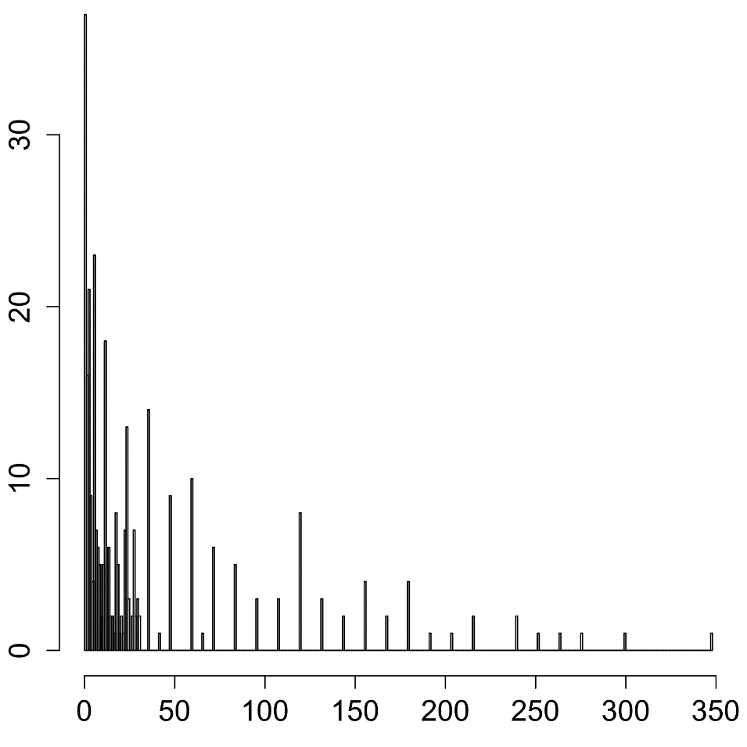
Number of patients
Months from cessation of cocaine use to relapse

Fig. S1: Distribution of the delay to relapse to cocaine use (months) in the human sample

Fig. S2: Linkage disequilibrium in 21 SNPs from the CHRNA5-A3-B4 cluster according to HAPLOVIEW

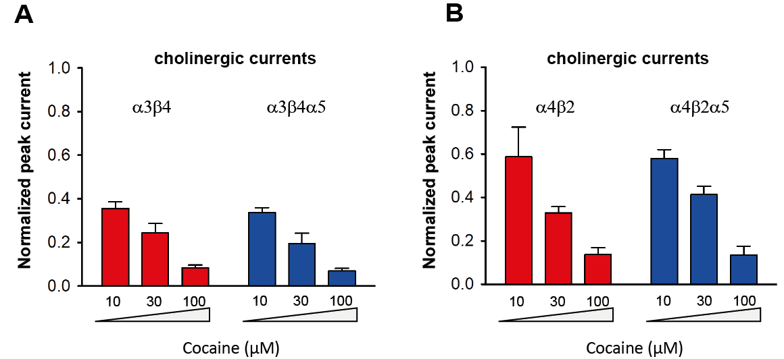

Fig. S3: (A) Absence of effect of the presence of the α5 subunit on cocaine-induced inhibition of cholinergic current on α3β4-containing nicotinic receptors in oocytes. Normalized peak current = Ipeak(ACh+cocaine)/Ipeak(ACh). Ach concentration: 30µM.
The two-way ANOVA performed on normalized peak current indicated a significant effect of cocaine concentration (F_{2,8}=40.02, p<0.0001; partial η²=0.91); but not of α5-subunit addition (F_{1,4}=3.16, p=0.15, NS; partial η²=0.35) and no interaction (F_{1,4}=2.37, p=0.16, NS; partial η²=0.37).
(B) Absence of effect of the presence of the α5 subunit on cocaine-induced inhibition of cholinergic current on α4β2-containing nicotinic receptors in oocytes.
Normalized peak current = Ipeak(ACh+cocaine)/Ipeak(ACh). Ach concentration: 30µM.
The two-way ANOVA performed on normalized peak current indicated a significant effect of cocaine concentration (F_{2,8}=39.03, p<0.0001; partial η²=0.9); but not of α5-subunit addition (F_{1,4}=0.12, p=0.75, NS; partial η²=0.04) and no interaction (F_{1,4}=0.51, p=0.62, NS; partial η²=0.11).
Mean and SEM are represented.

